LLM Graph Builder
Project guide: what it is, how it is built, and how it was set up

Source project: github.com/neo4j-labs/llm-graph-builder
Installed on: Intel MacBook (macOS), local installation
Date: 21 October 2026
Status: Installed, configured and tested end to end

Contents
1. Summary
Outcome at a glance
2. Key concepts
3. Architecture
Components
How the parts talk to each other
Why the backend runs in Docker
4. Workflow
A. Building the knowledge graph
What is stored in Neo4j
B. Asking questions (chat)
Chat modes
5. How it was set up
5.1 Starting point
5.2 Steps
5.3 Problems found and how they were fixed
6. Testing and verification
Relationships the AI extracted from the sample
Chat test
7. Using the application
Starting and stopping
Building a graph
Chatting
Looking at the graph in Neo4j Browser
8. Costs
9. Configuration reference
File locations
Important settings (secrets omitted)
Useful commands (Terminal)
10. Troubleshooting
11. Security and maintenance

Tip: if the contents list above is empty, right-click it in Word and choose “Update Field”.

1. Summary
LLM Graph Builder is an open-source application from Neo4j Labs. It reads unstructured content, such as PDFs, Word documents, text files and web pages, and turns it into a knowledge graph: a network of the people, organisations, places and ideas mentioned in the content, connected by the relationships between them. It then lets you chat with that graph, asking questions in plain English and getting answers that cite the original documents.
It works by combining three technologies:
- A Large Language Model (LLM), here OpenAI GPT-5.4 mini, which reads the text and identifies entities and relationships.
- A graph database (Neo4j), which stores those entities and relationships so they can be searched and explored.
- A local embedding model, which makes the text searchable by meaning rather than by exact words.
This document explains the project from end to end: the concepts behind it, its architecture, the step-by-step workflow, exactly how it was set up on this Mac (including problems found and how they were fixed), and how to use and maintain it.

Outcome at a glance
Item | Result
Frontend (web app) | Running on macOS at http://localhost:8080
Backend (processing engine) | Running in a Docker container at http://localhost:8000
Database | Local Neo4j 2025.10.1 with APOC, at bolt://localhost:7687
AI model | OpenAI gpt-5.4-mini (default) and gpt-5.5 (optional)
Embedding model | all-MiniLM-L6-v2, free, runs locally inside the backend
End-to-end test | Passed: sample document turned into 9 nodes and 20 relationships in 12 seconds; chat answered a two-step question correctly
Start / stop | Double-click Start Graph Builder.command / Stop Graph Builder.command

2. Key concepts
The terms below are used throughout this document.
Term | Plain-language meaning
Knowledge graph | A way of storing information as things (nodes) and the connections between them (relationships). For example: (Maria Lopez) –CEO_OF→ (Acme Robotics).
Node / relationship | A node is one thing (a person, company, document). A relationship is a named, directed link between two nodes.
Entity | A real-world thing the AI found in your text, such as a person, organisation, place, product or concept. Entities become nodes.
LLM | Large Language Model, an AI that reads and writes text (here, OpenAI GPT). Used to extract entities and to write chat answers.
Chunk | A small, overlapping piece of a document. Documents are split into chunks so the AI can process them one at a time.
Embedding | A list of numbers that represents the meaning of a piece of text. Texts with similar meaning have similar numbers, which enables “search by meaning”.
GraphRAG | Graph Retrieval-Augmented Generation. To answer a question, the app first retrieves relevant chunks and connected entities from the graph, then asks the AI to answer using only that material.
Cypher | Neo4j’s query language, used in Neo4j Browser to look at the graph directly.
APOC | A standard add-on library for Neo4j that provides extra procedures the app depends on.
Docker / container | Docker runs a small, self-contained Linux system (a container) on the Mac. The backend runs in one because some of its libraries are not available for Intel Macs.
API key | A secret password that lets the app use your OpenAI account. Usage is billed to that account.
.env file | A plain-text settings file holding addresses, usernames, passwords and keys. There is one for the backend and one for the frontend.

3. Architecture
The system has four main parts. Three run on the Mac (the frontend, the backend in Docker, and the Neo4j database) and one is an external service on the internet (OpenAI).
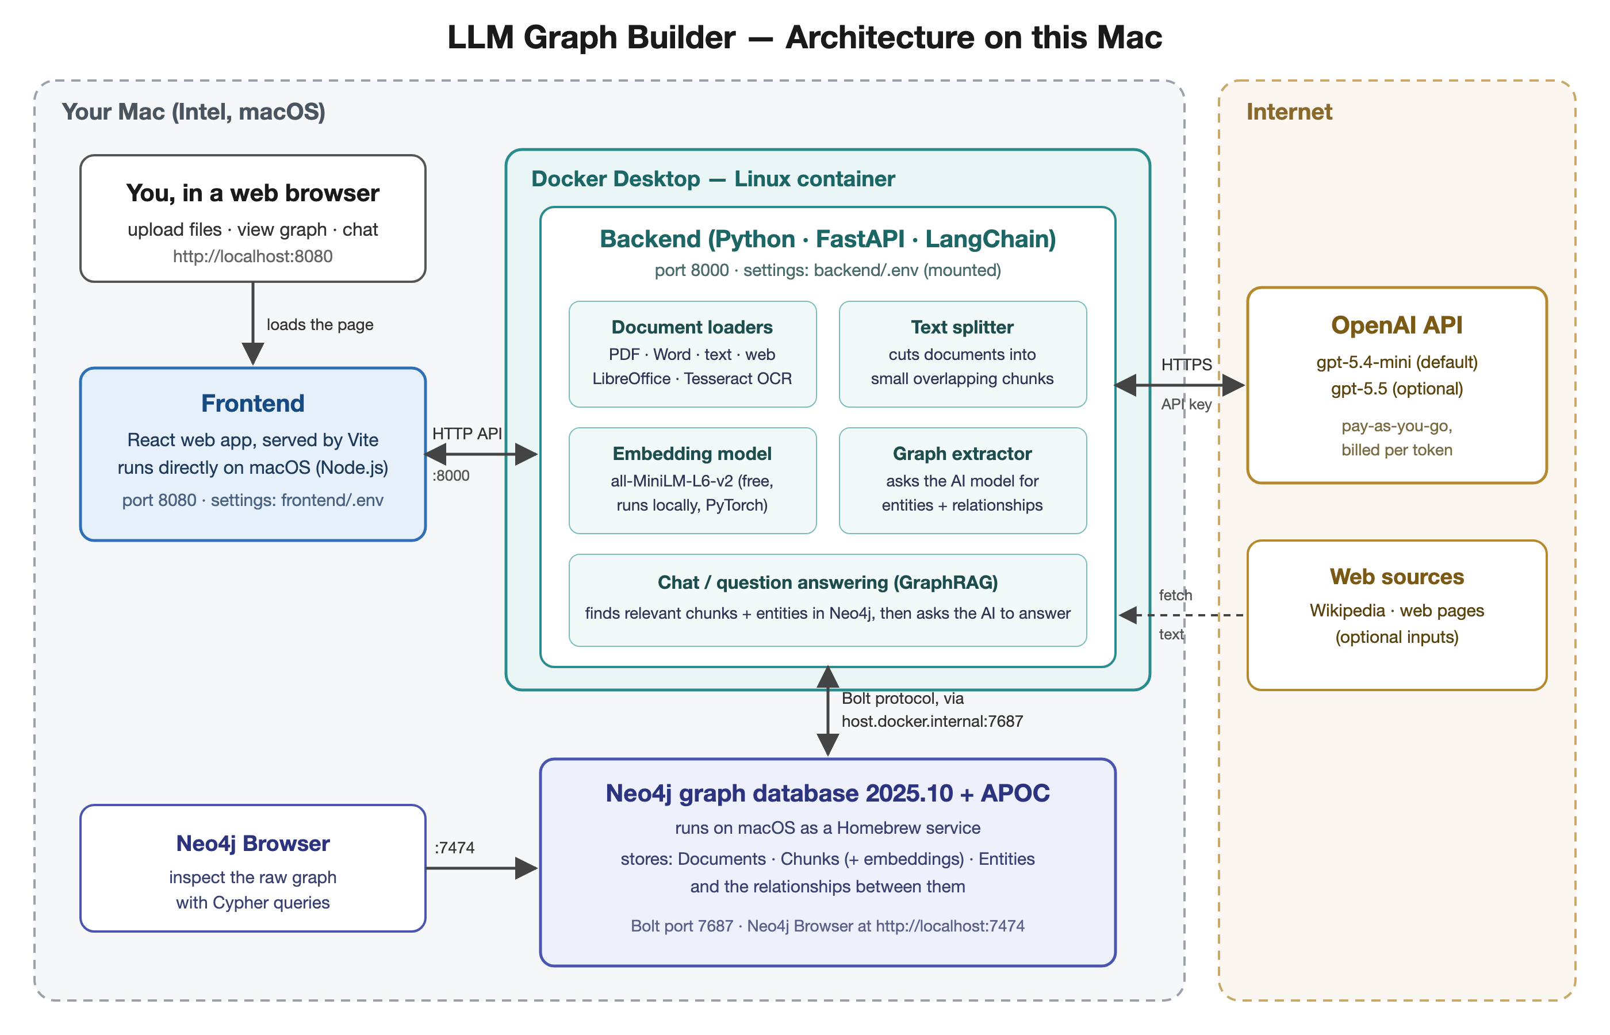
Figure 1. Architecture: the components and how they connect

Components
Component | Technology | Where it runs | What it does
Frontend | React + TypeScript, served by Vite (Node.js) | macOS, port 8080 | The web page you use to upload files, generate graphs, view them and chat.
Backend | Python 3.12, FastAPI, LangChain, gunicorn | Docker container, port 8000 | Loads and splits documents, creates embeddings, calls OpenAI, writes to Neo4j, answers chat questions.
Document loaders | unstructured, LibreOffice, Tesseract OCR, Poppler | Inside the backend | Extract text from PDFs, Word files, images and web pages.
Embedding model | all-MiniLM-L6-v2 via sentence-transformers / PyTorch | Inside the backend | Turns chunks and questions into 384-number vectors. Free, nothing leaves the Mac.
Graph database | Neo4j 2025.10.1 Community + APOC | macOS (Homebrew service), ports 7687 / 7474 | Stores documents, chunks, embeddings, entities and relationships; provides vector and full-text search.
Neo4j Browser | Built into Neo4j | Browser, port 7474 | A console for looking at the raw graph with Cypher queries.
LLM | OpenAI API, gpt-5.4-mini / gpt-5.5 | Internet (HTTPS) | Extracts entities and relationships; writes chat answers. The only paid component.

How the parts talk to each other
- Browser → Frontend: the browser loads the web app from localhost:8080.
- Frontend → Backend: the web app sends requests (upload, extract, chat and so on) to the backend’s HTTP API at localhost:8000.
- Backend → Neo4j: the backend connects over Neo4j’s Bolt protocol. Because the backend is inside Docker, it reaches the Mac through the special address host.docker.internal:7687.
- Backend → OpenAI: the backend calls the OpenAI API over HTTPS using the API key stored in backend/.env.
- Backend → web sources (optional): when you add a Wikipedia or web link, the backend fetches the page text.

Why the backend runs in Docker
The project’s backend depends on PyTorch 2.10 and onnxruntime 1.25 (needed by the document-parsing library). Neither is published for Intel-based Macs any more; the last Intel build of PyTorch is 2.2.2, which the parsing library rejects. A native install was attempted and failed for this reason. Docker solves it by running the backend in a Linux container, where those libraries are available. The frontend has no such limits and runs directly on macOS.

4. Workflow
There are two workflows: building a knowledge graph from a document (done once per document), and asking questions about it (done whenever you like).
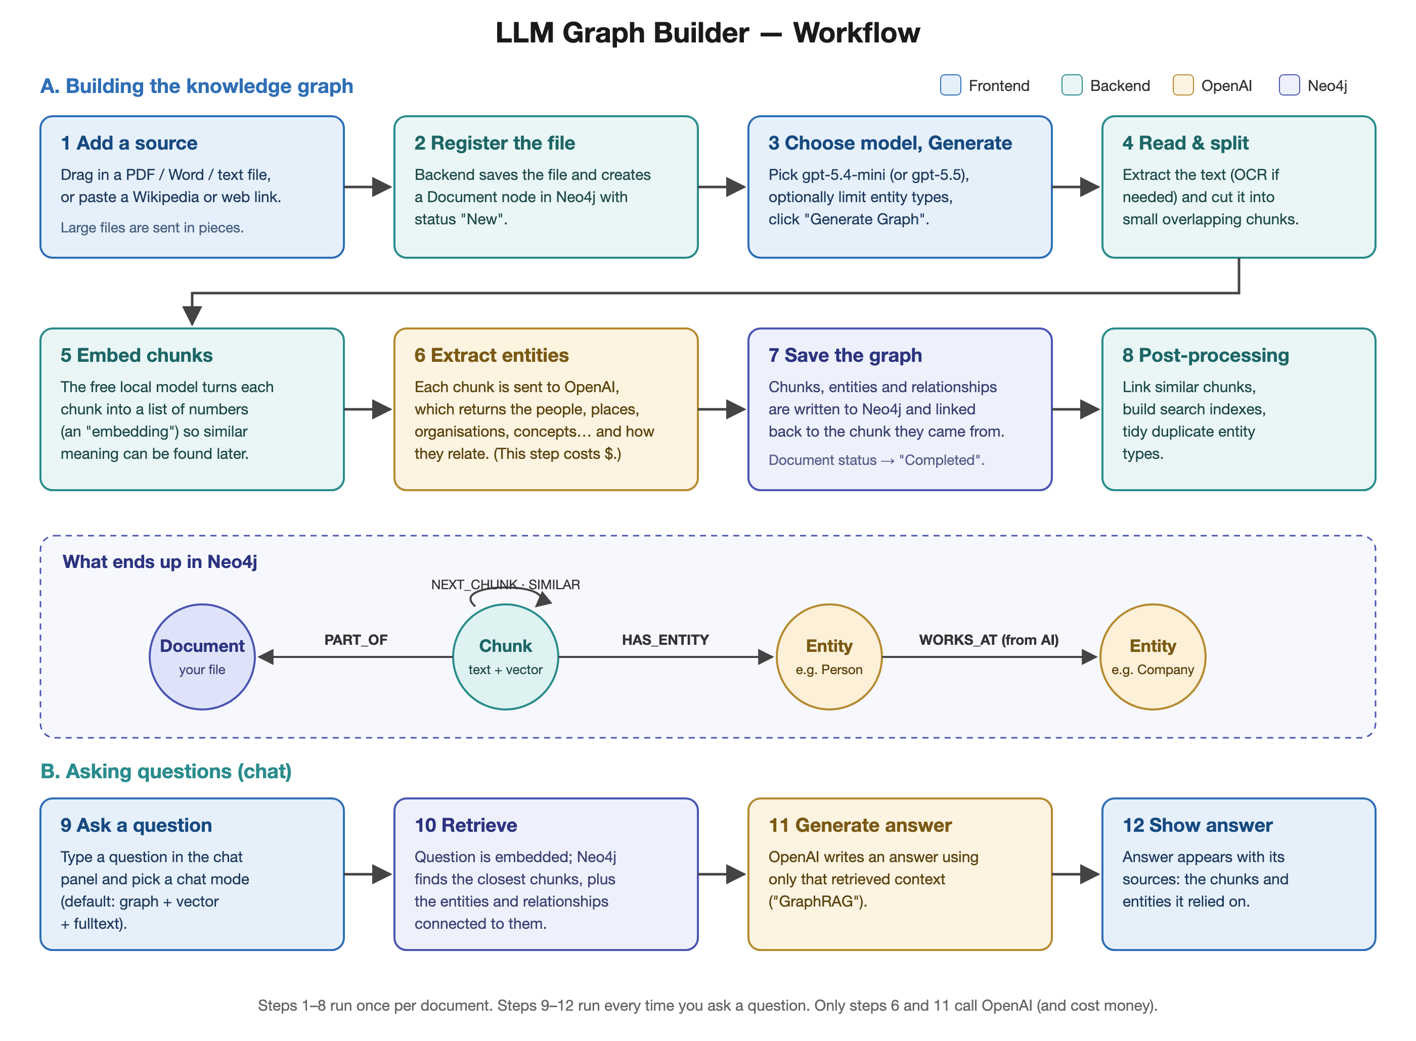
Figure 2. Workflow: building the graph (steps 1–8) and chatting with it (steps 9–12)

A. Building the knowledge graph
- Add a source. In the web app, drag in a file (PDF, DOCX, TXT and others) or add a Wikipedia or web page link. Large files are uploaded in pieces.
- Register the file. The backend stores the file and creates a Document node in Neo4j with the status “New”.
- Choose a model and click Generate Graph. Pick gpt-5.4-mini (cheaper) or gpt-5.5 (more capable). Optionally, in Graph Settings, restrict which kinds of entities and relationships to look for.
- Read and split. The backend extracts the text (using OCR for scanned pages) and splits it into small, overlapping chunks.
- Embed the chunks. The local embedding model converts each chunk into a vector and stores it on the chunk’s node.
- Extract entities and relationships. Each chunk is sent to OpenAI, which returns the entities it found and how they relate. This is the step that costs money.
- Save the graph. Entities and relationships are written to Neo4j and linked back to the chunk they came from. The document’s status becomes “Completed”.
- Post-processing. The backend links similar chunks, builds vector and full-text search indexes, and tidies up duplicate entity types.

What is stored in Neo4j
Element | Meaning
Document node | One per uploaded file or link; holds the file name, status, counts and model used.
Chunk node | A piece of the document’s text plus its embedding.
__Entity__ nodes | The things the AI found, also labelled with their type (Person, Organization, Location and so on).
PART_OF | Chunk → Document: which document a chunk belongs to.
NEXT_CHUNK | Chunk → Chunk: the reading order.
HAS_ENTITY | Chunk → Entity: which entities were found in a chunk (this is how answers are traced to sources).
SIMILAR | Chunk ↔ Chunk: chunks with very similar meaning (added during post-processing).
AI-named relationships | Entity → Entity, e.g. FOUNDED_BY, WORKS_FOR, USED_BY. Named by the AI from the text.

B. Asking questions (chat)
- Ask a question in the chat panel and choose a chat mode.
- Retrieve context. The question is embedded; Neo4j finds the closest chunks, the entities connected to them, and their relationships.
- Generate the answer. OpenAI writes an answer using only the retrieved context.
- Show the answer with its sources, so you can check which documents and chunks it relied on.

Chat modes
Mode | How it finds information
graph + vector + fulltext (default) | Combines meaning-based search, keyword search and graph connections. Best all-round choice.
vector | Finds chunks by meaning only.
fulltext | Finds chunks by keywords.
graph + vector | Meaning-based search plus graph connections.
graph | Has the AI write a Cypher query against the graph; good for counting and listing questions.
entity search + vector | Searches entities by meaning. Requires entity embeddings (off by default).
global search | Uses community summaries. Not available here: it needs the Neo4j Graph Data Science plugin, which this local Neo4j does not have.

5. How it was set up
This section records every step taken to install the project on this Mac, including the problems encountered and how they were solved. It can be used to repeat the setup on another machine.

5.1 Starting point
Item | Found
Computer | MacBook with Intel Core i7-9750H, 16 GB RAM, macOS
Already installed | Git, Python 3.13, Node.js 25, npm, Homebrew
Neo4j | Neo4j 2025.10.1 already installed via Homebrew and running as a background service (empty database)
Docker | Not installed

5.2 Steps
- Downloaded the project with Git into ~/llm-graph-builder.
- Attempted a native backend install (Python virtual environment + pip install -r requirements.txt). It failed because the pinned PyTorch build (torch==2.10.0+cpu) does not exist for macOS.
- Installed Python 3.12 with Homebrew and retried with PyTorch 2.2.2, the last Intel-Mac version. This also failed: unstructured-inference requires PyTorch ≥ 2.10 and onnxruntime ≥ 1.25, neither available for Intel Macs. Decision: run the backend in Docker.
- Installed the frontend dependencies with Yarn and created frontend/.env from frontend/example.env.
- Created the backend settings file (backend/.env) from backend/example.env, with token-usage tracking switched off (TRACK_USER_USAGE="false"); the template had it on, which would require a second database.
- Enabled APOC in Neo4j by copying apoc-2025.10.1-core.jar from Neo4j’s labs folder into its plugins folder and restarting Neo4j.
- Installed Docker Desktop (Intel version) and corrected the install: it had been launched from the installer disk image, so it was copied to Applications, its command-line links in ~/.docker were repointed, and the installer disk was ejected. Verified with Docker’s hello-world test.
- Configured the Neo4j login in backend/.env using the address bolt://host.docker.internal:7687, so the container can reach Neo4j on the Mac.
- Set up OpenAI: bought $5 of prepaid API credit (auto-reload off), created an API key, stored it in backend/.env, and verified it with a free model-listing request.
- Limited the model menu in frontend/.env to the two OpenAI models (VITE_LLM_MODELS="openai_gpt_5.4_mini,openai_gpt_5.5").
- Built the backend Docker image (llm-graph-builder-backend, about 9.6 GB) after adding a .dockerignore so that .env and stray files are not copied into the image.
- Started the backend container with the .env file mounted read-only, automatic restart, 2 workers instead of 8 to fit in Docker’s memory, and LD_LIBRARY_PATH cleared so LibreOffice works (see problem 7).
- Allowed APOC to run unrestricted in Neo4j’s configuration (see problem 4 below) and restarted Neo4j.
- Started the frontend on port 8080.
- Tested end to end (see section 6).
- Created Start / Stop scripts so the whole system can be started or stopped with a double-click.

5.3 Problems found and how they were fixed
# | Problem | Cause | Fix
1 | Backend packages would not install on macOS | PyTorch 2.10 and onnxruntime 1.25 are not built for Intel Macs | Run the backend in a Linux Docker container
2 | Neo4j did not come back after the first restart | The new instance started before the old one had shut down, then gave up | Re-registered the service with macOS (launchctl); later restarts stop fully before starting
3 | Docker command missing / Docker would vanish after reboot | Docker Desktop was running from the installer disk image | Copied it to Applications, repointed its CLI links, ejected the disk
4 | Backend could not connect: “apoc.meta.data is unavailable because it is sandboxed” | Neo4j sandboxes APOC procedures by default | Added dbms.security.procedures.unrestricted=apoc.* to neo4j.conf (original kept as neo4j.conf.backup-before-apoc)
5 | Project’s docker-compose.yml would blank out the keys | Its environment: section overrides .env with empty values from the shell | Run the backend with plain docker run and mount .env instead
6 | Risk of running out of memory | Default of 8 gunicorn workers, each loading the embedding model | Run with 2 workers × 8 threads
7 | LibreOffice inside the backend would not start, breaking older formats such as .doc, .ppt and .rtf | The project Dockerfile sets LD_LIBRARY_PATH, which hides LibreOffice’s own libraries | Container runs with -e LD_LIBRARY_PATH= (cleared); verified by parsing a .doc file

6. Testing and verification
Each part was checked on its own and then the whole pipeline was tested with a short sample document about a fictional company (“Acme Robotics”), using the same backend calls the web app makes.
Check | Result
Docker engine | Running; hello-world container succeeded
Neo4j login and APOC | Login OK; APOC 2025.10.1 loaded; database neo4j online
OpenAI key | Accepted; gpt-5.4-mini and gpt-5.5 available on the account
Backend → Neo4j connection | “Backend connection successful”, write access confirmed, vector size 384
Upload | Document node created for acme_test.txt
Graph extraction (gpt-5.4-mini) | Completed in 12.2 s: 9 nodes, 20 relationships
Post-processing | All tasks completed (similarities, indexes, schema consolidation)
Chat (graph + vector + fulltext) | Correct answer with source cited (below)
Start / Stop scripts | Full stop then start: all services came back and reconnected
LibreOffice in backend (older Word formats) | After fix: a .doc file was parsed successfully

Relationships the AI extracted from the sample
Sample text (abridged): “Acme Robotics … founded in 2019 by Maria Lopez and David Chen in Austin, Texas … builds warehouse robots called PickBot, which are used by Northwind Logistics … opened a second office in Toronto, Canada, led by engineer Priya Shah. Priya Shah previously worked at Northwind Logistics.”
From | Relationship | To
Acme Robotics | FOUNDED_BY | Maria Lopez; David Chen
Acme Robotics | FOUNDED_IN | Austin, Texas
Acme Robotics | BUILDS | PickBot
Acme Robotics | OPENED_OFFICE_IN | Toronto, Canada
Maria Lopez | CEO | Acme Robotics
David Chen | CHIEF_TECHNOLOGY_OFFICER | Acme Robotics
PickBot | USED_BY | Northwind Logistics
Toronto, Canada | LED_BY | Priya Shah
Priya Shah | WORKS_FOR | Acme Robotics
Priya Shah | WORKED_AT | Northwind Logistics

Chat test
Question: Who leads the Toronto office, and where did that person work before?
Answer: Priya Shah leads the Toronto office, and she previously worked at Northwind Logistics. (Source: acme_test.txt)
This answer needed two facts from different sentences, joined through the graph. The sample document was left in the database so it can be explored; it can be removed from the web app with Delete Files.

7. Using the application

Starting and stopping
Two shortcut files are in the llm-graph-builder folder in your home folder:
- Start Graph Builder.command: double-click to start everything. It checks Neo4j, opens Docker if needed, starts the backend and frontend, and opens the app in your browser.
- Stop Graph Builder.command: stops the backend and frontend. Neo4j and Docker are left running.
First time only: macOS may say the file “cannot be opened because it is from an unidentified developer”. Right-click the file, choose Open, then Open again. After that, double-clicking works.

Building a graph
- Open http://localhost:8080. The app connects to Neo4j automatically (the login is in backend/.env).
- Drag a document into the upload area, or use Web Sources for a Wikipedia or web page link.
- Choose the model (gpt-5.4-mini is the cheaper default).
- Optional: open Graph Settings to limit the kinds of entities and relationships, or add instructions for the AI.
- Tick the file(s) and click Generate Graph. Progress is shown in the file table; status changes to “Completed”.
- Click Preview Graph to see the result.

Chatting
Open the chat panel, type a question, and press Enter. Use the mode selector to change how the app searches (see section 4). Each answer shows its sources; click them to see the exact chunks and entities used.

Looking at the graph in Neo4j Browser
Open http://localhost:7474 and log in with Connect URL neo4j://localhost:7687, username neo4j and the database password. Useful queries:
// Show part of the graph
MATCH (n) RETURN n LIMIT 100

// List entities and how they are connected (excluding documents and chunks)
MATCH (a:__Entity__)-[r]->(b:__Entity__) RETURN a.id, type(r), b.id

// Count everything per document
MATCH (d:Document) RETURN d.fileName, d.status, d.nodeCount, d.relationshipCount

8. Costs
Item | Cost
LLM Graph Builder, Neo4j Community, Docker Desktop (personal use), embedding model | Free
OpenAI API | Pay-as-you-go from prepaid credit. $5 was added with auto-reload off, so spending cannot exceed the balance.
Only two steps call OpenAI: entity extraction when building a graph (cost grows with document length) and answer writing in chat. The sample test cost a fraction of a cent. gpt-5.4-mini is much cheaper than gpt-5.5; use the larger model only when extraction quality matters. Current usage and balance are shown at platform.openai.com under Usage.
A ChatGPT subscription does not include API usage; the two are billed separately.

9. Configuration reference

File locations
Path | Purpose
~/llm-graph-builder/ | The project (downloaded from GitHub)
~/llm-graph-builder/backend/.env | Backend settings: Neo4j login, OpenAI key, model configuration. Contains secrets.
~/llm-graph-builder/frontend/.env | Frontend settings: backend address, model list, chat modes
~/llm-graph-builder/backend/.dockerignore | Keeps .env and clutter out of the Docker image (added during setup)
~/llm-graph-builder/Start Graph Builder.command | Start script (added during setup)
~/llm-graph-builder/Stop Graph Builder.command | Stop script (added during setup)
~/llm-graph-builder/frontend-dev.log | Frontend log
/usr/local/Cellar/neo4j/2025.10.1/libexec/conf/neo4j.conf | Neo4j configuration (APOC setting added at the end)
/usr/local/Cellar/neo4j/2025.10.1/libexec/plugins/ | Neo4j plugins (APOC jar added)
/usr/local/var/log/neo4j.log | Neo4j log

Important settings (secrets omitted)
Setting (file) | Value
NEO4J_URI (backend) | bolt://host.docker.internal:7687
NEO4J_USERNAME / NEO4J_DATABASE (backend) | neo4j / neo4j
NEO4J_PASSWORD (backend) | (set; not shown)
OPENAI_API_KEY (backend) | (set; not shown)
LLM_MODEL_CONFIG_OPENAI_GPT_5_4_MINI (backend) | gpt-5.4-mini,<api key>
LLM_MODEL_CONFIG_OPENAI_GPT_5_5 (backend) | gpt-5.5,<api key>
TRACK_USER_USAGE (backend) | false
EMBEDDING_PROVIDER / EMBEDDING_MODEL (backend) | blank, so the defaults are used: sentence-transformer / all-MiniLM-L6-v2
VITE_BACKEND_API_URL (frontend) | http://localhost:8000
VITE_LLM_MODELS (frontend) | openai_gpt_5.4_mini,openai_gpt_5.5
VITE_SKIP_AUTH (frontend) | true (no login screen)

Useful commands (Terminal)
# Backend container status and recent log
docker ps --filter name=llm-graph-builder-backend
docker logs --tail 50 llm-graph-builder-backend

# Restart the backend (e.g. after editing backend/.env)
docker restart llm-graph-builder-backend

# Neo4j service
brew services info neo4j
brew services restart neo4j

# Recreate the backend container (if it is ever deleted)
docker run -d --name llm-graph-builder-backend -p 8000:8000 -e LD_LIBRARY_PATH= \
-v "$HOME/llm-graph-builder/backend/.env:/code/.env:ro" \
--restart unless-stopped llm-graph-builder-backend \
gunicorn score:app --workers 2 --threads 8 \
--worker-class uvicorn.workers.UvicornWorker --bind 0.0.0.0:8000 --timeout 300

10. Troubleshooting
Symptom | What to check / do
Web page does not load | Run Start Graph Builder.command. Check that nothing else is using port 8080.
App says it cannot connect to the backend | Is Docker Desktop open (whale icon in the menu bar)? Run docker ps; if the backend is missing, run the start script.
“Unable to connect backend DB” | Is Neo4j running (brew services info neo4j)? Has its password changed? Then update backend/.env and run docker restart llm-graph-builder-backend.
Extraction fails with an OpenAI error | Check the credit balance and that the key is still active at platform.openai.com.
A file stays “Processing” or fails | Look at docker logs --tail 100 llm-graph-builder-backend. Very large or scanned PDFs take longer.
Backend crashes on large files | Increase Docker’s memory: Docker Desktop → Settings → Resources.
Changed a setting and nothing happened | Backend settings: restart the container. Frontend settings: stop and start the frontend.

11. Security and maintenance
- backend/.env holds the database password and the OpenAI API key. Do not share it, email it or commit it to Git (the project’s .gitignore already excludes it).
- If an API key is ever exposed (for example pasted into a chat or shared document), revoke it at platform.openai.com/api-keys, create a new one, update the three places it appears in backend/.env, and restart the backend.
- Neo4j only listens on this Mac (localhost), and the app has no login (VITE_SKIP_AUTH=true). This is fine for personal local use; do not expose these ports to a network without enabling authentication.
- Updating the project: git pull in ~/llm-graph-builder, then rebuild the image (docker build -t llm-graph-builder-backend backend), remove the old container and recreate it with the command in section 9, and run yarn install in frontend.
- Back up the graph by stopping Neo4j and copying its data folder, or with neo4j-admin database dump.

